Title I School-Wide Parent Involvement Policy
Greenville High
2016-2017

Statement of Purpose

Greenville High School is committed to providing quality education programs and establishing high levels of performance for all children. Title I law requires that each school develop jointly with parents a policy which describes how the school intends to comply with the requirements of this law. The following policy will be distributed to all parents, and this policy will be revised annually based on the results of the Title I Survey done each spring. Because parent involvement and support are essential components for each child to be successful, the school is committed to establishing a home-school partnership to ensure academic success for every child.

Parental Involvement

Greenville High School believes that parental involvement means the participation of parents in a regular two-way, and meaningful communication involving student academic learning and other school activities, including ensuring (A) That parents play an integral role in assisting their child’s learning; (B) That parents are encouraged to be actively involved in their child’s education; and (C) That parents are full partners in their child’s education and are included, as appropriate, in decision making and on advisory committees to assist in the education of their child.
- Greenville High will hold an annual Title I Meeting to review the Title I Plan and School Parent Involvement Policy.

- Offer flexible meeting times and varied activities designed to support and encourage the involvement of all parents;

- Involve parents in planning, reviewing, and improving the Title I program, including the School and District Parent Involvement Policy by:
- Reviewing results of the Title I Survey
- Revising the policy based on survey results
- Encouraging parents to participate on the PAC (Parent Advisory Council)
- Encouraging parents to participate on the School Councils

- Provide timely information about the Title I Program, the academic curriculum, assessments used to measure progress, grade level expectations, and opportunities to interact with teachers regarding the education of their children by way of:
- Newsletters
- Student handbook
- Information will be available in the Parent Resource Center
- Report Cards
- Parent Conference Days
- School Website
- Social Media (Facebook)

- Provide information and assistance to parents regarding the state and local academic standards and assessments by ways of the following:
- Parent Conferences
- Parent meetings/workshops
- Report Cards

- Provide necessary materials, handouts, and training for parents at conferences, meetings, and activities to help parents work with their child to improve their child’s achievement.
- Parent Expo (Taste of Curriculum Night)
- Articles with tips for parents
- Workshops

- Provide training for staff on strategies to improve communication with parents and ideas to increase family engagement.
- P.I.C staff will also share best practices during the school year.
- Professional Learning on parental involvement will be offered.

- Educate the academic community regarding the value of parent involvement, ways to communicate effectively with parents, and implementation of parent programs;
- Greenville High School values parent involvement and takes pride in providing a friendly and welcoming environment. Faculty, Staff, and Administration strive to create a feeling of community between the families and the school.

- Provide opportunities for parent involvement activities requested by parents;
- Parents are encouraged to make their suggestions and requests known through communication with the building administration and through membership in the PAC and School Council. Parents can also make requests known at parent meetings.

- Provide Title I funds for parent involvement activities;
- The Title I Coordinator allocates Title I funds to Greenville High to be used for parent involvement. These funds are used for all parent activities and/or materials for parent workshops.

- Establish a school and division Parent Advisory Council;
- Input and suggestions from parents are an essential component of the district and school improvement plans. All parents of students eligible to receive Title I services are invited to attend two meeting opportunities to share their ideas and suggestions to help the district, schools, and students to reach our student academic goals.
- State of the District Meeting---May 22, 2017
- School Improvement Forums---May 2-5, 2017
- Unable to attend the District meetings, please visit www.mcssga.org to review the meeting documents and provide your input.

Parent Resource Center
- Come visit the Parent Resource Center to get important school information. Parents can also check out books and study materials. Computers are available for parents to explore the Parent Portal, other educational resources, or job resources.

Shared Responsibilities for G.H.S Student Academic Achievement

Greenville High School will develop jointly with parents, students, and teachers a School/Parent/Student Compact that will ensure high academic achievement. The compact will outline ways in which the parents, school staff, and students will work together to strengthen the school and home partnership.
Parents, students, and teachers at Greenville High School will sign a Parent/Teacher/Student compact each year. This compact is;
- Shared and developed jointly by the PAC and School Council Members which includes parents, teachers, and administrators.
- Sent home to all parents
- Provided for parents in the Parent Resource Center
- Discussed with parents at conferences and parent meetings; Parents will have opportunities to make comments in regards to any revisions.
- Placed on the School website
- Revised annually

Building Capacity for Involvement

Greenville High will host the following events to build the capacity for strong parental involvement to support a partnership among the school, parents, and the community to improve student achievement. The school will offer flexible times for meetings/activities for parents.
- Open House
- Annual Title I Meeting
- What Parents Need To Know About IEPS
- Parent Engagement Day—Parent Pop Up Day
- Parent Expo/Taste of Curriculum Night
- Student Registration Days
- Academic Carnival
- Technology Talk
- Flexible Learning Program (FLP)
- Senior Parent Night
Parent Involvement Evaluation
Each year, the district and the schools will send home a survey to parents to provide valuable feedback regarding the parental involvement activities and programs. The surveys will be posted on the website as well as paper copies will be available to parents that request it. These surveys will help to evaluate the content and effectiveness of the parental involvement policy and parental involvement activities as well help to improve the academic quality of the Title I schools.

Accessibility
Greenville High School will:
Make parent involvement accessible to all parents including parents with limited English proficiency, parents with disabilities, and parents of migratory children including providing information and school reports in a language parents can understand.
Greenville High School will ensure that parent involvement activities are accessible to all parents by;
- Providing ESOL staff to communicate with families
- Making sure that information sent home to parents is in a language they can understand
- Working with the district parent involvement coordinator when collaboration is needed with the Office for Student Support Services

Adoption
This policy was developed jointly and agreed upon with parents of children participating in the Title I, Part A programs. The policy was adopted by the School Council and Parent Advisory Council and will be in effect for 2016-2017. The policy will be distributed to the entire parent population at Greenville High School.

Nicole Hopson- Parent
Joshua Toombs- Parent
Antonio Owens – Instructional Coach
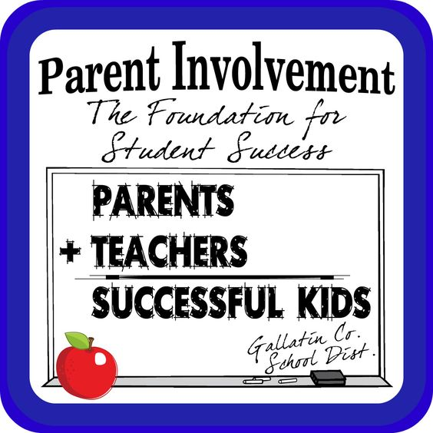
Thaddeus Jackson – Greenville High School Principal
Russell Jeter III- Greenville High School Assistant Principal
Makeisha Butler- Instructional Coach
Gladys Birts- Counselor
Jerry Parkerson- Teacher
Eric Poythress- Teacher
Leslie Chadwick- Teacher
Brandy Perry- Teacher
Vanessa Brown- Teacher

Plan Revised September 15, 2016

