[](http://www.google.com/url?sa=i&rct=j&q=&esrc=s&source=images&cd=&cad=rja&uact=8&ved=0CAcQjRw&url=http://thehypeagency.com/news-views/12/26/14-things-learned-2014-communication/&ei=iidqVYTxCtH_yQTppYCwDg&bvm=bv.94455598,d.cGU&psig=AFQjCNFTmTcVUBnSONHH8Mcrj7XWrUxs6A&ust=1433106595211902)[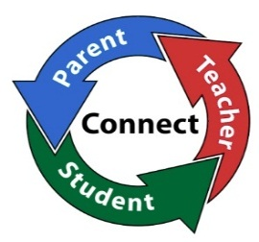](http://www.google.com/url?sa=i&rct=j&q=&esrc=s&source=images&cd=&cad=rja&uact=8&ved=0CAcQjRw&url=http://hains.rcboe.org/&ei=rCpqVZX9L4qbyATw9ICABA&bvm=bv.94455598,d.cGU&psig=AFQjCNFNJmfsINMEn-0MxEqDKIAvdbj5Ow&ust=1433107475749951)

***Activities to Build Partnerships***

***Communication about***

***Student Learning***

***Fgfffhfdhf\\\\\\\\\\\\\\\\\\\\\\\\\\\\***

*learning*

**School-Family Compact**

**2016-2017**

Greenville High School

17656 Roosevelt Highway

Greenville, GA 30222

(706) 672-4930

<http://meriwetherghs.weebly.com/>

“Prep for success at GHS”

It is an agreement that families, teachers, and students review and update annually that explains how all stakeholders will work together to make sure **ALL** students reach their academic potential and graduate from high school. The compact signed by parents, students and faculty describes how each will be responsible for supporting academic learning. The school-family compact remains at home to be reviewed by the student and parent. It will be discussed throughout the school year at different family engagement programs and parent-teacher conferences.

At GHS, many forms of communication are used to share information about student learning. These forms include:

* Open House
* Emails
* Phone Call/One Call
* Conferences
* Text messages
* Parent Resource Center
* Infinite Campus (Parent Portal)
* School Website

This compact is revised each year by all stakeholders involved to identify the current academic needs of GHS. Many opportunities are provided for all stakeholders to share ideas with regard to what is most needed for the educational success of all students. These opportunities include school council meetings, faculty meetings, conferences, emails, and parent meetings.

There are many opportunities for parents, teachers, and students to build partnerships throughout the school year:

* Conferences
* Title 1 Meetings
* Parent Workshops
* Senior Night
* Student Registration
* Volunteering
* Family Engagement Programs

***What is a  
 School-Parent Compact?***

***Jointly Developed***

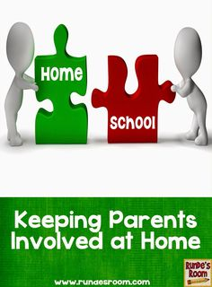

***Our Goals for Student Achievement***

**Greenville High Goals & Focus Areas:**

* Increase student Lexile scores by 10% for 2016-17 school year.
* Increase student mastery of standards
* Increase % of students taking dual enrollment courses in high school by 3% in the 2016/2017 school year.

**Meriwether County School**

**District Goals:**

1. Promote *Excellence and Academic Achievement* in all Meriwether County schools.
2. Improve *Organizational and Operational Effectiveness* in the Meriwether County School District.
3. Increase *Parent and Community Involvement* in all Meriwether County schools.
4. Meriwether County schools will continue to *Grow a* *Quality Organization* of highly effective faculty and staff members.

***Revision Date: August 22, 2016***

***Student Responsibilities***

**We, as students, will:**

* Come to school with all supplies and prepared to learn
* Show respect for myself, my school and other people.
* Follow all school rules
* Communicate with my parents about school events and meetings
* Be held accountable for academic growth and progress
* Take pride in our school and work hard to be successful

***Family***

***Responsibilities***

**We, as parents, will:**

* Ensure that my child comes to school prepared to learn each day
* Support the school in developing positive behaviors.
* Ensure that my child follows school/classroom rules.
* Make sure we attend school related functions such as: *conferences, parent meetings, academic nights, etc.*
* Stay aware of what my child is learning.
* Provide a home environment that encourages my child to learn.

***School/Teacher Responsibilities:***

**We as teachers will:**

* Come to class prepared to teach and believe that every child can learn
* Show respect for each student and his/her family.
* Enforce school and classroom rules fairly.
* Seek ways to involve parents in the school program.
* Schedule parent conferences on various dates and times of the day.
* Provide a safe learning and welcoming learning environment that encourages our students to learn

***Teachers, Parents, and Students—Together for Success***